Report:

Building different models by hypertunning the parameters with different number of hidden layers, and number of units and two different types of techinque(Regularization and drop out).

Parameter metrics:

|  |  |  |  |  |  |
| --- | --- | --- | --- | --- | --- |
| No.of units | Hidden layers | Activation Func | Techinque | Accuracy | loss |
| 16 | 1 | tanh | - | 0.86 | 0.1 |
| 16 | 1 | tanh | regularization | 0.86 | 0.16 |
| 16 | 1 | tanh | reg& dropout | 0.87 | 0.14 |
| 64,32,16 | 3 | tanh | - | 0.85 | 0.15 |
| 64,32,16 | 3 | tanh | regularization | 0.86 | 0.11 |
| 64,32,16 | 3 | tanh | reg & dropout | 0.85 | 0.12 |
| **64,32,16** | **3** | **relu** | **regularization** | **0.88** | **0.15** |

By observing the results of different models, we can say that the models with 1 hidden layer model with tanh and relu, accuracy is higher in traning dataset than vailidation. So this model may not perform well perform on test data. So we build the models with 3 different layers and hypertuned it.

Tanh_activation

Building a model with regularization function with tanh activation. This has three hidden layers with 64,32,16 units respectively.

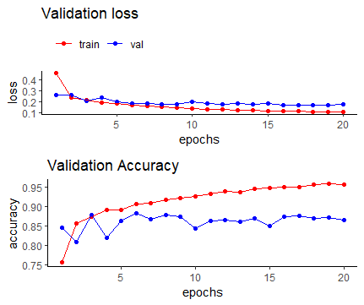

From the above graph it is hard to state from where the model is getting over fitted so choosing epoch value is difficult in this model. By this we can say that this model is not stable.

Relu_activation

Building a model with regularization function with relu activation. This has three hidden layers with 64,32,16 units respectively.

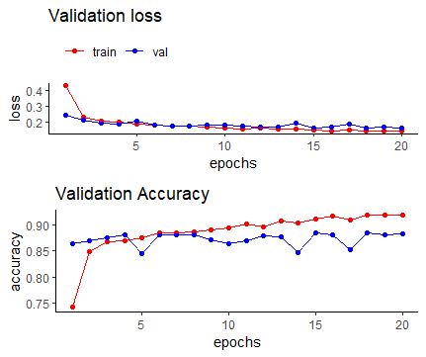

When we used relu function the model is stable and can be distinguished clearly where the model is getting over fitted.

Conclusion:

We examined above models with tanh and relu activation functions using different layers. By observations we can clearly distinguish where the model is getting over fitted using relu activation function where as in tanh it is hard to find where the model is getting over fitted.